Ministry of Higher Education
LANDMARK METROPOLITAN UNIVERSITY INSTITUTE (LMUI) BUEA
“Training Productive Leaders”


School: Landmark School of Science, Engineering and Technology
Department: Software Engineering
Design and Implementation of a Decentralized Fee Verification System for Mobile Money Transactions in Cameroonian Universities

A Project Report Submitted in Partial Fulfilment of the Requirements for the Award of a
Bachelor of Technology (BTech) Degree in Software Engineering

Presented by
Efeme Royal
LMUI24-SWE288
Supervisor
Mr. Kah Kissinger
Academic Year
2025/2026

CERTIFICATION
This is to certify that this Project Report, written and presented to Landmark Metropolitan University Institute by Efeme Royal in partial fulfilment of the requirements for the award of a Bachelor of Technology (BTech) Degree in Software Engineering is original and suitable for public presentation.

STUDENT

………………………………

SUPERVISOR

………………………………
DATE ……………………….

DATE …………………………

CO-SUPERVISOR

………………………………

DATE …………………………

DEDICATION
To …

ACKNOWLEDGEMENTS
Firstly, I extend my deepest gratitude to my supervisor, Engr. Kah Kissinger, for their vital guidance, insightful feedback, and steadfast support throughout this project.
I would like to thank my teammates for their collaborative efforts in brainstorming and testing the system to ensure maximum functionality.
Lastly, I owe a heartfelt thanks to my family and friends for their encouragement, tenacity and patience during the long hours of research and development.

ABSTRACT
The verification of fee payments in Cameroonian universities remains a largely manual and fraud-vulnerable process. Mobile Money (MoMo) services, despite their widespread adoption, have failed to gain institutional trust as payment proof mechanisms due to the ease with which SMS confirmations and payment screenshots can be forged. This gap was most visibly demonstrated in 2024 when the University of Buea reversed a five-year mobile payment initiative and returned to traditional bank-based transactions, citing the need for greater financial control. This project proposes and implements TrustPay, a decentralized fee verification protocol designed specifically for higher education institutions in Cameroon. TrustPay integrates a hybrid architecture combining a Node.js and MongoDB backend with a React.js frontend and a Solidity-based smart contract deployed on the Polygon Amoy Testnet. Upon successful payment, the system generates a cryptographically signed receipt using HMAC-SHA256 and mints a non-transferable Soulbound Token (ERC-5192) to the student's wallet, permanently binding proof of payment to the paying individual. Bursary administrators can verify student payments in real time via QR code scanning or manual reference entry through a dedicated dashboard. Evaluation through unit, integration, and system testing demonstrates that the system effectively prevents receipt forgery, eliminates duplication, and reduces verification time significantly compared to existing manual processes. TrustPay demonstrates that blockchain technology, when applied with discipline and scope awareness, can solve real administrative problems in developing economies without requiring institutional infrastructure overhaul.
Keywords:

TABLE OF CONTENTS
Contents
CERTIFICATION i
DEDICATION ii
ACKNOWLEDGEMENTS iii
ABSTRACT iv
TABLE OF CONTENTS v
LIST OF ABBREVIATIONS vi
LIST OF TABLES ix
LIST OF FIGURES xi
CHAPTER ONE: GENERAL INTRODUCTION 1
1.1 Introduction 1
1.2 Background of the Study 1
1.3 Statement of the Problem 2
1.4 Objectives of the Study 2
1.4.1 General Objective 2
1.4.2 Specific Objectives 2
1.5 Significance of the Study 3
1.6 Scope of the Study 4
1.7 Definition of Terms 4
1.8 Organization of the Study 5
CHAPTER TWO: LITERATURE REVIEW 6
2.1 Introduction 6
2.2 Review of Related Concepts 6
2.2.1 Blockchain Technology 6
2.2.2 Soulbound Tokens (SBTs) 6
2.2.3 Hybrid Architecture 7
2.3 Review of Related Works 7
2.3.1 Project Name: Blockcerts. 7
2.3.2 Project Name: EduChain (Academic Credential Management System) 8
2.3.3 Project Name: Blockchain Fee Payment System: Algeria Case Study 8
2.3.4 Project Name: B-ACVS (Academic Credential Verification System) 8
2.4 Proposed Solution (TrustPay) 9
2.4.1 Localized Fintech Integration (Mobile Money Bridge) 9
2.4.2 The Soulbound Lock: Eliminating Identity Fraud 9
2.4.3 Dual-Pathway Verification: Cross-Platform QR and NFC Protocols 10
CHAPTER THREE: MATERIALS AND METHODS 12
3.1 Introduction 12
3.2 Development Methodology 12
3.2.1 Agile Methodology 12
3.2.2 The Agile Phases for TrustPay 13
3.3 Tools and Materials Used 13
3.3.1 Hardware Requirements 14
3.3.2 Software Requirements 14
3.4 System Modules 16
3.4.1 Client-Side Module (Frontend) 16
3.4.2 Payment Gateway Module (Middleware) 17
3.4.3 Blockchain & Smart Contract Module 17
3.4.4 Notification & Event Module 17
3.5 System Analysis 18
3.5.1 Functional Requirements 18
3.5.2 Non-Functional Requirements 18
3.5.3 Cost Evaluation 19
3.5.5 Use Case Analysis 20
3.5.6 Sequence Diagram 20
3.5.7 Activity Diagram 24
3.6 System Design 25
3.6.1 System Architecture 25
3.6.2 System Design Strategy 25
3.6.3 Class Diagram 26
3.6.5 Data Dictionary 28

LIST OF ABBREVIATIONS
API: Application Programming Interface
CID: Content Identifier
DeFi: Decentralized Finance
ERC: Ethereum Request for Comments
ERD: Entity-Relationship Diagram
GSAP: GreenSock Animation Platform
HMAC: Hash-based Message Authentication Code
HTTPS: Hypertext Transfer Protocol Secure
IPFS: InterPlanetary File System
JWT: JSON Web Token
MoMo: Mobile Money
MTN: Mobile Telephone Networks
NFT: Non-Fungible Token
NoSQL: Non-Structured Query Language
QR: Quick Response
RBAC: Role-Based Access Control
REST: Representational State Transfer
SBT: Soulbound Token
SHA: Secure Hash Algorithm
STK: SIM Toolkit
UB: University of Buea
UML: Unified Modelling Language
UUID: Universally Unique Identifier
Web3: Third Generation of the World Wide Web
WSS: WebSocket Secure
XAF: Central African CFA Franc

LIST OF TABLES

Table 1: Student Entity 28
Table 2: Admin Entity 28
Table 3: Transaction Entity 29
Table 4: Receipt Metadata 29
Table 5: Smart Contract State 30

LIST OF FIGURES

CHAPTER ONE: GENERAL INTRODUCTION

1.1 Introduction
The integration of blockchain technology and decentralized finance (DeFi) has introduced a shift in how digital trust and identity are managed across various socio-economic sectors. In the realm of academic administration, the rapid advancement of automated payment verification systems has revolutionized student services, significantly reducing wait times and improving accessibility to essential institutional resources. This project focuses on the design and implementation of TrustPay, a blockchain-based verification protocol specifically tailored for higher education institutions in Cameroon. By leveraging Soulbound Tokens (SBTs) and decentralized ledgers, the project seeks to enhance the user experience for students through the provision of intelligent, real-time, and tamper-proof transaction responses. The primary goal is to move beyond traditional, easily manipulated digital receipts toward a secure, context-aware verification framework that ensures financial integrity and administrative transparency within the university ecosystem.

1.2 Background of the Study
In recent years, several academic institutions in Cameroon, most notably the University of Buea (UB), have attempted to adopt mobile payment solutions for the fee collection process. At first, these systems were a huge win for convenience, but the whole thing fell apart due to their inability to prove the authenticity of transactions on the spot. [reference] This created a massive loophole that people quickly exploited for fraud. [reference] Consequently, institutions like UB were forced to execute a "rollback" to traditional bank payments for the 2024/2025 academic year. [reference]
This reversal has placed students at a significant disadvantage, reintroducing the logistical burden of standing in long, exhausting lines at financial institutions. Such delays often result in students missing critical lectures and laboratory sessions. Furthermore, the requirement for physical cash transactions introduces a major security risk, as students are forced to carry large sums of money in high-traffic campus environments. The current system moved backward because it failed to address the fundamental problem of digital trust and verifiable identity. [reference]

1.3 Statement of the Problem
The fundamental challenge facing university fee management today is not the transfer of funds, but the verification of the transaction's integrity. Currently, students lack a reliable way to prove that their digital transactions are 100% authentic in a manner that university administrators can trust instantly. Conversely, university staff lack a streamlined, technological method to distinguish a valid payment from a "Photoshopped" screenshot or a forged SMS alert.
Standard Mobile Money (MoMo) receipts are typically delivered as static images or text messages, formats that are fundamentally easy to forge using basic graphic editing tools. This verification gap makes the reconciliation process for the bursary department slow, hectic, and prone to human errors. Without a decentralized anchor for these payments, the university cannot fully embrace digital transformation because they are still held back by manual checks, resulting in financial leakages and operational bottlenecks.

1.4 Objectives of the Study

1.4.1 General Objective
The primary goal of this research is to build TrustPay, a system that uses blockchain technology to create a secure, authentic way to manage school fees. By using Soulbound Tokens (SBTs), the project aims to give Landmark Metropolitan University Institute a verification framework where receipts aren't just pieces of paper or digital images, but permanent, tamper-proof records that can be trusted by everyone.

1.4.2 Specific Objectives
- Design a hybrid system architecture: A "hybrid" approach is used to get the best of both worlds. The goal is to design a system that connects the fast, everyday world of Mobile Money APIs (MTN/Orange) with the high-security world of a decentralized blockchain. This ensures that while the payment is quick, the record of that payment is anchored on a ledger that no one can change later.
- Develop a Smart Contract for Soulbound Tokens (SBTs): The main goal here is to write the code for the smart contract that automatically creates a digital receipt the moment a payment is confirmed. By making these receipts "Soulbound", we ensure they are tied to one student and cannot be sent, sold, or shared with anyone else.
- Implement a student interface and an admin dashboard: For this system to be useful, it needs to be easy to use. This objective focuses on building a clean web app where students can pay their fees without confusion, and a professional dashboard for the bursary staff. The dashboard will include a QR-code scanner so that an admin can verify a student's payment status in a matter of seconds.
- Evaluate system performance and reconciliation speed: The final step is to prove that the system actually works better than the old way. This means testing how well TrustPay stops forgery attempts and measuring how much faster the university can perform reconciliation when they don't have to manually check every single bank teller or MoMo message.

1.5 Significance of the Study
This study provides a practical technological solution to an administrative problem, offering benefits to multiple participants:
- To the University (LMUI): The project provides a transparent, real-time financial overview. Automating verification, it eliminates the risk of internal or external revenue leakages caused by fraudulent digital receipts.
- To the Students: The implementation removes the physical and emotional burden associated with bank queues. It allows students to focus on academic research and lectures while eliminating the security risks associated with carrying physical cash.
- To the Field of Software Engineering: This project serves as a practical implementation of Web3 technology in a developing economy. It demonstrates that decentralized protocols and Soulbound Tokens can solve real-world problems beyond the scope of cryptocurrency and speculative finance.

1.6 Scope of the Study
The research is specifically focused on the fee payment and verification processes at Landmark Metropolitan University Institute (LMUI).
- Functional Scope: The system is limited to handling tuition fee payments via MTN Mobile Money and the issuance of Soulbound Tokens (SBTs) as digital proof of payment.
- Technical Scope: The implementation involves a hybrid architecture utilizing React.js and Node.js for the frontend and backend interfaces, respectively, and Solidity for the blockchain logic. Also, TrustPay utilizes a verification logic. For office-based reconciliation on PCs, the system leverages Webcam-based QR recognition.
- Limitations: This study does not extend to non-academic payments such as cafeteria fees, hostel bookings, or transcript processing. It is intended to complement, rather than entirely replace, existing banking infrastructures by providing a secure digital alternative for transaction verification.

1.7 Definition of Terms
- Blockchain: A decentralized, distributed digital ledger technology that records transactions across a network of computers to ensure data cannot be altered retroactively.
- Soulbound Token (SBT): A non-transferable digital asset on a blockchain that represents an individual’s credentials or identity; once issued, it cannot be sold or transferred to another user.
- Mobile Money (MoMo): A financial service provided by mobile network operator (MTN) that allows users to store, send, and receive money via mobile devices.
- Tamper-Proof: A characteristic of a system or record designed to be resistant to unauthorized modification or interference.
- Smart Contract: A self-executing contract with the terms of the agreement between the payer and the institution directly written into the blockchain code.

1.8 Organization of the Study
This project is organized into five distinct chapters. Chapter One provides the general introduction, outlining the problem, objectives, and significance of the study. Chapter Two reviews existing literature on blockchain and payment systems while proposing the technical conceptual framework. Chapter Three details the materials and methods used to construct the TrustPay protocol, including the software and hardware requirements. Chapter Four focuses on the implementation phase, presenting the code, system architecture, and testing results. Finally, Chapter Five provides a summary of findings, conclusions, and recommendations for the future scalability of the system.

CHAPTER TWO: LITERATURE REVIEW

2.1 Introduction
This chapter reviews the theoretical and empirical foundations of digital payments and blockchain technology. It explores how decentralization can solve the "Trust Gap" identified in Chapter One and examines existing solutions to identify where they succeed and where they fail to meet the needs of Cameroonian students.

2.2 Review of Related Concepts

2.2.1 Blockchain Technology
Blockchain is a distributed ledger technology that redefines how data is trusted. In traditional university systems, the "source of truth" is a central database managed by a few administrators. If that database is tampered with or if the server goes offline, the truth is lost or corrupted. It becomes a point of failure.
Blockchain changes this by distributing the ledger across a network of nodes. Every transaction, that is, every fee payment, is bundled into a "block" and cryptographically hashed. Once a block is added to the chain, it becomes immutable, meaning it cannot be deleted or edited without altering every subsequent block, which is computationally impossible. This means that once a student’s payment is recorded on the blockchain, it becomes a permanent, transparent, and auditable fact that does not rely on the honesty of a single person or the security of a single central server.

2.2.2 Soulbound Tokens (SBTs)
Standard Non-Fungible Tokens (NFTs) gained fame as digital collectibles that can be bought, sold, or traded; they are not suitable for academic receipts. If a fee receipt were a regular NFT, a student could pay their fees and then send or sell that digital receipt to another student, who could then use it to fraudulently claim they had paid.
Soulbound Tokens (SBTs), a concept popularized by Vitalik Buterin, solve this transferability problem. SBTs are digital identity tokens that are permanently "bound" to a specific private wallet (the "Soul"). They cannot be moved once they are issued. In the context of TrustPay, the SBT acts as a digital seal of payment. Because it is non-transferable, it ensures that the credit for paying tuition stays with the student who actually paid. This makes SBTs the ideal digital upgrade to a physical bank stamp; it is personal, permanent, and impossible to share.

2.2.3 Hybrid Architecture
A common critique of blockchain is that it can be slow or expensive (due to high gas fees) if every single small action is put on the chain. To solve this for a high-traffic environment like a university bursary, TrustPay utilizes a Hybrid Architecture. This model uses two layers:
- Off-Chain Database (The Speed Layer): The project uses a traditional database (like PostgreSQL or MongoDB) via Node.js to handle the immediate tasks. When a student clicks "Pay," the initial transaction data, user profile, and temporary status are stored here. This provides the instant feedback and high-speed performance students expect from a modern web app.
- On-Chain Ledger (The Security Layer): The final proof, the transaction hash, and the minting of the SBT are pushed to the blockchain.
By using this hybrid approach, we ensure the system is fast enough for daily use (off-chain) but remains cryptographically anchored in a way that is impossible to forge (on-chain). It prevents the system from lagging during peak registration periods while maintaining the truth that only a blockchain can provide.

2.3 Review of Related Works

2.3.1 Project Name: Blockcerts.
- Author: MIT Media Lab & Learning Machine (2016).
- Technology: Bitcoin and Ethereum Blockchain, Open-source standard.
- Strengths: It is the global standard for blockchain-based credentials. It allows for permanent, universally verifiable academic certificates that students own forever.
- Limitations: It is designed for static certificates (like diplomas) rather than dynamic workflows (like tuition payments). It lacks integration with local payment gateways like Mobile Money, making it unusable for daily fee collection in Cameroon.

2.3.2 Project Name: EduChain (Academic Credential Management System)
- Author: EduChain Team (2024).
- Technology: Consortium Blockchain (Hyperledger/Ethereum hybrid).
- Strengths: Highly efficient at managing student records and grade transcripts across different departments. It uses a hybrid model to keep personal data private while making credentials public.
- Limitations: The infrastructure is heavy and requires significant server resources that most resource-constrained institutions cannot maintain. It focuses on academic records rather than the immediate financial trust gap at the bursary.

2.3.3 Project Name: Blockchain Fee Payment System: Algeria Case Study
- Author(s): Zeroual et al. (2025).
- Technology Used: Ethereum Smart Contracts.
- Strengths: One of the few academic projects specifically targeting registration fees. It automated the issuance of digital receipts upon payment.
- Limitations/Recommendations: It relies heavily on traditional digital wallets (like MetaMask), which have a steep learning curve for the average student. Furthermore, it does not address the "receipt sharing" problem, regular digital receipts can still be screenshotted and sent to others.

2.3.4 Project Name: B-ACVS (Academic Credential Verification System)
- Author(s): Al-Enazi et al. (2024).
- Technology Used: SHA3-512 Algorithm, Hybrid Blockchain.
- Strengths: Excellent security and very fast verification times using high-level encryption.
- Limitations/Recommendations: It requires significant RAM and hardware power to run the verification algorithms, making it difficult for administrators to verify receipts on standard mobile phones or low-end office computers.

2.4 Proposed Solution (TrustPay)
While the related works reviewed in the previous section demonstrate the power of blockchain in academics, they often fail to address the unique socio-economic and technical realities of the Cameroonian educational landscape. TrustPay is proposed not merely as a payment portal, but as a specialized verification protocol designed to bridge the trust gap at Landmark Metropolitan University Institute (LMUI). The solution improves upon existing systems in three critical ways:

2.4.1 Localized Fintech Integration (Mobile Money Bridge)
Existing global systems like Blockcerts or EduChain are built on the assumption that users have access to credit cards, bank accounts, or pre-funded cryptocurrency wallets (like MetaMask). In the Buea context, this is a major barrier. Most students rely exclusively on MTN Mobile Money or Orange Money for their daily transactions.
TrustPay solves this by implementing a Payment Gateway Bridge. Instead of requiring students to understand gas fees or private keys, the system integrates directly with local MoMo APIs. When a student initiates a payment, the backend handles the complex handshake between the mobile network operator and the blockchain. This allows a student to pay with a simple prompt on their phone while the system silently secures that transaction on a decentralized ledger. This localized fintech approach ensures the system is inclusive and actually usable by the average student.

2.4.2 The Soulbound Lock: Eliminating Identity Fraud
A significant limitation found in the Algeria Case Study and standard digital receipt systems is the Transferability Loophole. In those systems, a digital receipt is often just a file or a standard NFT. This creates a fraud risk where a student pays their fees, receives a digital receipt, and then "shares" or "sends" that receipt to another student, who uses it to deceive the bursary.
TrustPay eliminates this by utilizing Soulbound Tokens (SBTs). Unlike regular NFTs, SBTs are non-transferable. Once the TrustPay smart contract verifies a payment, it mints a token that is hard-coded to the student’s specific digital identity (their "Soul"). Because these tokens cannot be moved to another wallet, they act as an immutable, non-shareable digital seal. This ensures that the credit for a payment stays with the person who actually made it.

CHAPTER THREE: MATERIALS AND METHODS

3.1 Introduction
This chapter outlines the methodologies, technical tools, and architectural designs employed to develop TrustPay, a blockchain-based payment verification protocol. Building on the objectives established in Chapter One, specifically the elimination of receipt fraud at institutions like The University of Buea and Landmark Metropolitan University Institute, this section justifies the selection of a decentralized framework.
Upon launch of the project an iterative development approach was adopted, allowing for iterative refinement of smart contract logic and network efficiency. The chapter covers the hardware and software requirements, system modules including the API Gateway, and specialized network considerations such as WebSocket integration for real-time transaction updates and latency optimization for mobile users.

3.2 Development Methodology
To ensure the successful delivery of TrustPay, the Iterative Development Model was selected as the primary methodology. This choice is particularly suited for a project of this nature, one that involves external API integrations with Mobile Money providers, evolving blockchain standards, and a high-stakes financial transaction layer where errors discovered late are costly to reverse. Unlike traditional linear models, the Iterative Model allows each component of TrustPay to be built, tested, and refined in cycles, meaning security vulnerabilities and performance bottlenecks are caught and addressed early rather than surfaced at the end of development.

3.2.1 Iterative Model
The development is divided into iterative cycles, each producing a working, testable increment of the system. This approach is particularly well-suited to TrustPay's high-stakes financial transaction context. Rather than assembling the full system before testing begins, each iteration delivers a functional piece that is evaluated and improved before the next cycle starts.
In the context of TrustPay, the iterative cycle allowed for repeated optimization of the latency between the MTN MoMo payment callback, the backend processing chain, and the blockchain minting event. Because blockchain transactions can face network congestion that cannot be predicted upfront, the iterative approach enabled progressive stress-testing of the handshake between the MoMo APIs and the Polygon network across multiple cycles, ensuring response times stayed within acceptable limits for students in varying network conditions.

3.2.2 The Iterative Phases for TrustPay
The project followed these four distinct phases within each iteration:
- Planning: Defining the specific capability to be built in concrete terms, for example, "As a student, I want to receive my digital receipt within ten seconds of confirming my payment."
- Design and Development: Writing Solidity smart contracts (ERC-5192) and building the React frontend and Node.js backend logic for that iteration's target increment.
- Network and Security Testing: Using Postman for API reliability and webhook behaviour verification, and Hardhat for smart contract simulation, gas optimization, and local network testing.
- Review and Deployment: Deploying the working increment to the Polygon Amoy Testnet, evaluating it against the defined user story, and identifying what the next iteration needs to address.
In comparing development frameworks, the Waterfall Model was considered but ultimately deemed unsuitable. Its rigid, linear structure requires every requirement to be finalized upfront, which does not account for the unpredictable nature of blockchain gas fees or potential breaking changes in third-party Mobile Money APIs. The Spiral Model was also evaluated, while it offers strong risk analysis, its heavy documentation cycles make it a bottleneck for a student-led prototype, where deployment speed is essential.
The Iterative Model was therefore selected as the most effective approach for TrustPay. It supports a development environment where smart contract security and network efficiency can be refined simultaneously across cycles, critical for continuously monitoring and optimizing the communication latency between the frontend interface, the payment gateways, and the decentralized ledger.

3.3 Tools and Materials Used
The development of TrustPay requires a combination of high-performance computing hardware and specialized software protocols to ensure the blockchain remains synchronized with local payment gateways.

3.3.1 Hardware Requirements
To maintain a reliable development and testing environment, the following hardware specifications are utilized:
- Development Station: A laptop with at least 8GB RAM and an Octa-core processor to handle concurrent processes, including a local blockchain node (Hardhat), the React development server, and other backend-related services.
- Mobile Testing Devices: Android and iOS devices are used to simulate the student's end-user experience, specifically testing the responsiveness of the STK Push notifications from MTN MoMo.
- Cloud Hosting (Production): Deployment on Vercel (Frontend) and Render (Backend) to provide 99.9% uptime using free-tier cloud infrastructure.
- Networking Hardware: High-speed broadband with low-latency routing is essential for maintaining a stable connection to the Polygon RPC nodes to prevent "dropped" transactions during the minting of Soulbound Tokens.

3.3.2 Software Requirements
The software stack is selected to prioritize security, low latency, and ease of verification.
- Operating System: Windows 10 or 11, or Linux (Ubuntu) for a stable development environment.
- Blockchain & Smart Contract:
  - Solidity: The primary programming language for writing the ERC-5192 (Minimal Soulbound Token) smart contracts.
  - Polygon Amoy Testnet: The specific network used for deployment and testing (utilizing free test-MATIC).
  - Hardhat: A professional development environment for compiling, deploying, and debugging Solidity contracts locally.
  - OpenZeppelin: Industry-standard library utilized for secure, audited contract templates (specifically for EIP-165 and ERC-721 extensions).
  - MetaMask: A browser-extension wallet used as the administrative interface for signing transactions and managing the University's "Issuer" account.
- Frontend Development:
  - React.js & Tailwind CSS: Core framework for building the user interface and managing component-based architecture.
  - GSAP (GreenSock Animation Platform): Used for advanced UI/3D animations to provide high-end visual feedback during the asynchronous minting process.
- Communication Protocols:
  - WebSockets (WSS): Used for real-time bidirectional communication. This ensures the UI updates instantly the moment a block is confirmed.
  - HTTPS/REST: For secure communication between the TrustPay server and the Mobile Money API endpoints.
- Backend & API Integration:
  - Node.js & Express: The server-side environment used to create the API Gateway and handle Mobile Money webhooks.
  - Ethers.js: The library that allows the backend and frontend to interact with the Polygon blockchain.
  - Postman: Essential for testing the RESTful API endpoints and simulating successful payment responses from MTN/Orange.
  - Etherscan / Polygonscan: For verifying transaction hashes and ensuring the ERC-5192 properties are correctly applied on-chain.

- Data & Storage:
  - IPFS (via Web3.Storage): A decentralized storage protocol used to host receipt metadata, ensuring data remains immutable and off-chain at zero cost.
  - MongoDB Atlas: A cloud-hosted NoSQL database (M0 Free Cluster) used for internal logging of transaction histories and user account mapping.

3.4 System Modules
In alignment with Software Engineering principles, the TrustPay architecture is decomposed into highly cohesive, loosely coupled modules. This modular approach ensures that the blockchain logic, payment processing, and user interface remain independent, allowing for easier debugging and scalability.

3.4.1 Client-Side Module (Frontend)
The user-facing layer is built using React and Tailwind CSS to provide a high-end, responsive experience.
- State Management: Utilizes React Hooks to manage the lifecycle of a payment, from the initial "Push" request to the final "Success" state.
- Animation Engine (GSAP): Implements visual feedback during the "Minting" process. Since blockchain transactions aren't instantaneous, GSAP provides smooth, 3D-like progress indicators to maintain user engagement while the network confirms the block.
- Wallet Integration: Uses Ethers.js to provide a seamless handshake between the web application and the user’s decentralized identity (SBT Vault).

3.4.2 Payment Gateway Module (Middleware)
This module acts as the bridge between traditional mobile finance and the decentralized ledger.
- API Manager: Developed with Node.js, this sub-module listens for incoming webhooks from MTN MoMo or Orange Money.
- Verification Logic: Before triggering any blockchain action, this module performs a "Check-Sum" to ensure the amount paid matches the fee required by the university database, preventing unauthorized minting attempts.

3.4.3 Blockchain & Smart Contract Module
This is the core trust layer of the system, where the actual digital assets are managed.
- Minting Controller: A Solidity-based module that implements the ERC-5192 (Soulbound) standard. It ensures that once a receipt is generated, the `transfer()` function is disabled, binding the receipt permanently to the student's wallet address.
- Metadata Handler: Manages the communication with IPFS (via Pinata). Instead of storing heavy PDF files on-chain, this module uploads the receipt details to decentralized storage and saves only the cryptographic hash (CID) to the smart contract to save on gas costs.

3.4.4 Notification & Event Module
To provide a real-time "Web2-like" feel in a Web3 environment, this module handles all status updates.
- Real-time Handlers: Uses WebSockets to push notifications to the student’s dashboard the moment a transaction is "Mined" on the Polygon network.
- Logging System: A backend service that records every attempted, failed, and successful transaction for administrative auditing and dispute resolution.

3.5 System Analysis

3.5.1 Functional Requirements
These define the specific actions the TrustPay system must perform:
- Student Authentication & Wallet Linking: The system shall allow students to authenticate their university identity and securely link their MetaMask wallet to their profile for receipt storage.
- Payment Gateway Integration: The system shall initiate an MTN MoMo or Orange Money "STK Push" request immediately upon the student selecting a fee category.
- Automated Transaction Verification: The Node.js middleware shall listen for and validate payment confirmation webhooks from the telecommunications provider before authorizing any blockchain action.
- SBT Minting & Distribution: Upon payment confirmation, the system shall automatically trigger a smart contract on the Polygon Amoy Testnet to mint a non-transferable ERC-5192 Soulbound Token to the student's wallet.
- Metadata Immutability: The system shall upload receipt details (Student ID, Date, Amount) to IPFS via Web3.Storage and store the resulting CID hash on the blockchain.
- Administrative Verification Portal: The system shall provide a dashboard for university staff to verify a student’s payment status by querying the blockchain using a QR code or wallet address.
- History & Data Logging: The system shall record all successful transactions in MongoDB Atlas and allow users to view their history and export receipts as PDFs.

3.5.2 Non-Functional Requirements
These define the quality standards and technical constraints of the system:
- Security (Non-transferability): The system shall utilize the ERC-5192 standard to permanently disable the `transfer()` function, ensuring receipts cannot be shared or sold.
- Performance (Real-time Feedback): The system shall update the frontend UI via WebSockets within 5 seconds of a transaction being confirmed on the blockchain.
- Scalability: The MongoDB Atlas and Render-hosted backend shall be capable of handling at least 1,000 concurrent payment requests during peak registration periods.
- Reliability: The system shall maintain 99.9% uptime by leveraging a hybrid architecture of cloud-hosted gateways and decentralized storage (IPFS).
- Cost-Efficiency: The system shall minimize gas consumption by using Polygon, ensuring the cost per receipt generation remains below $0.01 (≃ 6 XAF).
- Usability & Visuals: The interface shall use GSAP animations to provide clear, high-end visual feedback during the "Minting" and "Success" states to manage user expectations during block confirmations.
- Interoperability: The API gateway shall follow RESTful standards, allowing it to be easily integrated into existing university portals (like the UB student portal) in the future.

3.5.3 Cost Evaluation
The economic model for TrustPay is built on a Zero-Budget Academic Strategy, prioritizing the use of "Free Forever" tiers to eliminate operational overhead during the development phase. By utilizing the Polygon Amoy Testnet, the system can mint thousands of digital receipts using free test-MATIC obtained from network faucets, effectively removing the burden of transaction gas fees that would otherwise be a significant issue in a mainnet environment.
For the application’s infrastructure, the backend logic is hosted on Render, which provides a free tier for Node.js environments, while all transaction logging and student identity mapping are handled by MongoDB Atlas. By utilizing the M0 Free Cluster, the project gains access to a professional-grade NoSQL database with 512MB to 5GB of storage at no cost, which is more than sufficient for storing thousands of payment records. The frontend is deployed via Vercel’s Hobby Tier, which offers professional-grade hosting, automated deployments, and a free SSL certificate under a custom subdomain.

Finally, decentralized data persistence for the receipt metadata is achieved through Web3.Storage, a protocol that leverages IPFS and Filecoin to store immutable data at no cost for smaller-scale projects. This hybrid approach ensures that the total monthly expenditure for the prototype remains at 0 XAF, demonstrating a fiscally efficient engineering solution that is ready to scale to paid enterprise tiers, such as AWS, only when the institution moves toward a full-scale production launch.

3.5.5 Use Case Analysis

3.5.6 Sequence Diagram
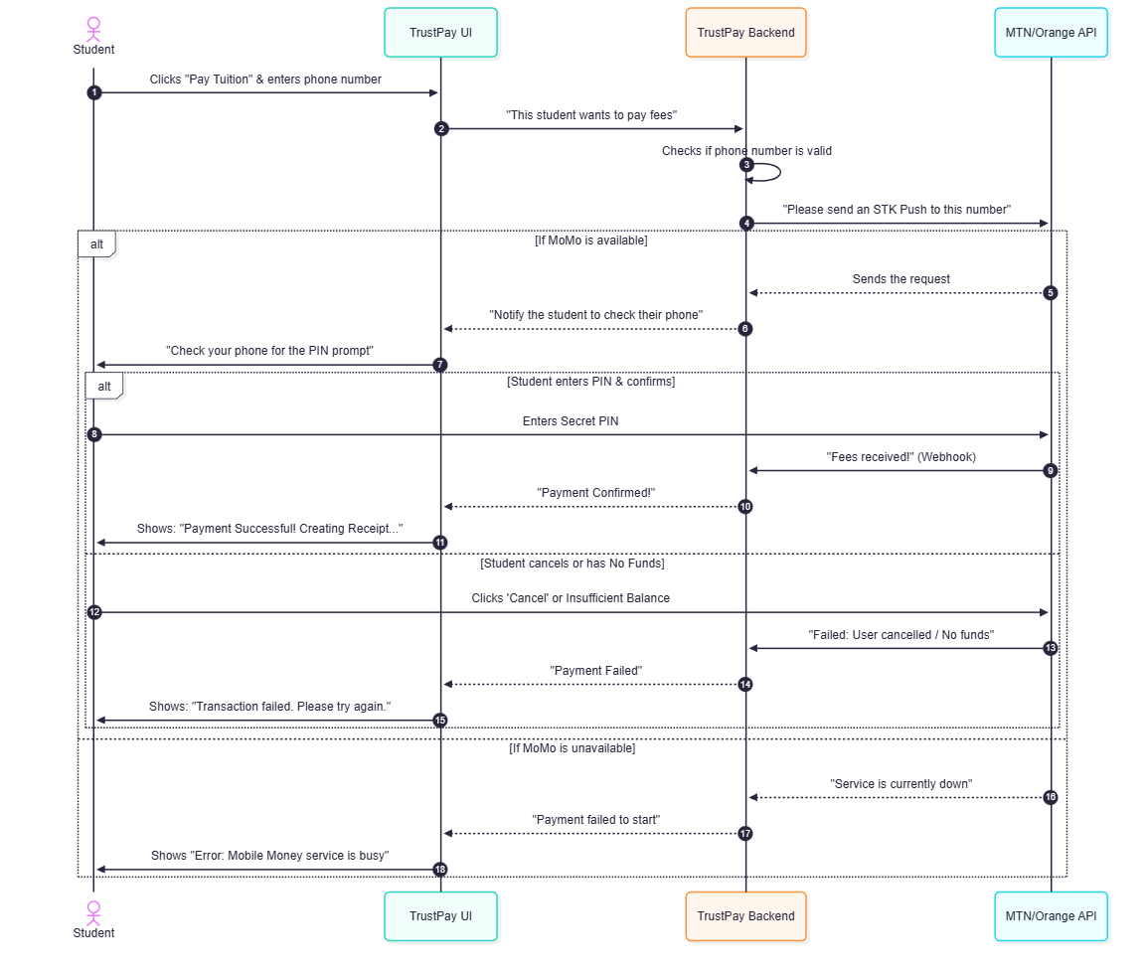Figure 1: Full payment flow sequence diagram
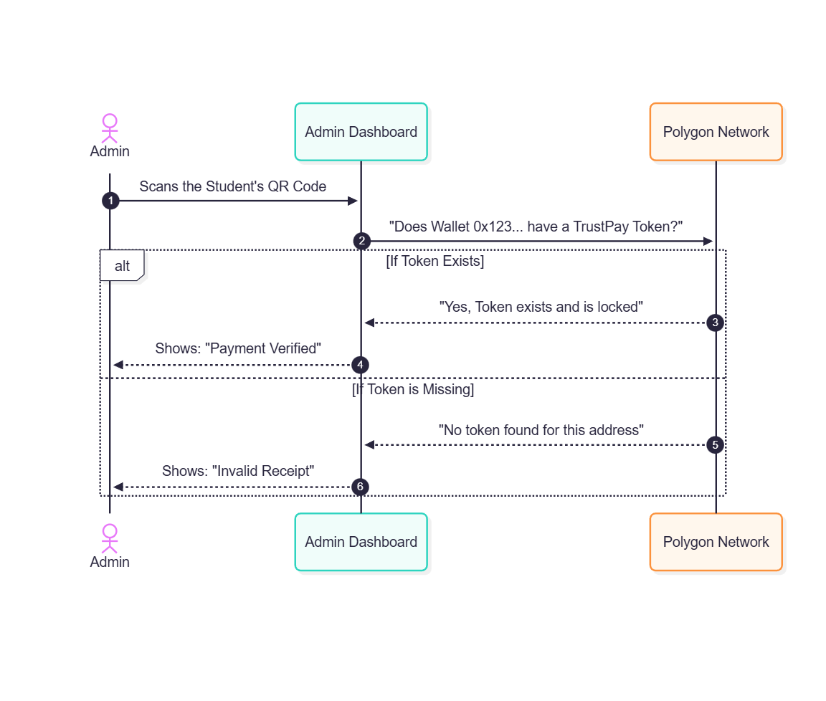Figure 2: Admin fee verification sequence diagram
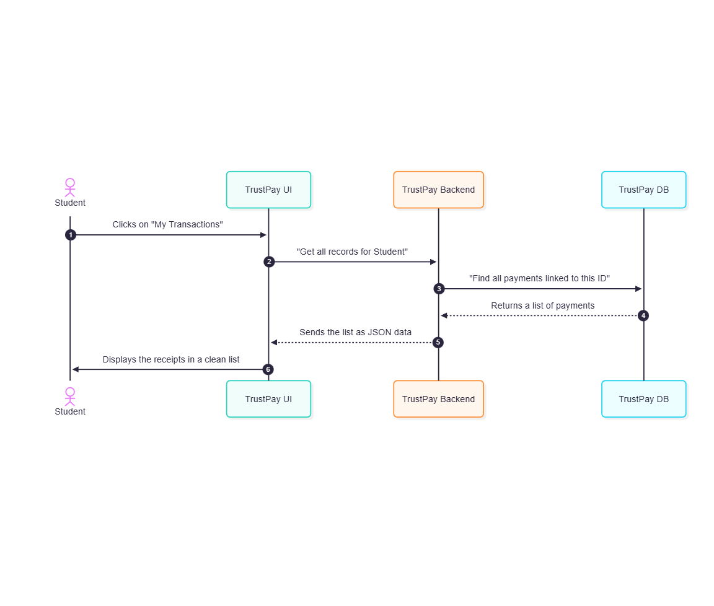Figure 3: Database retrieval sequence diagram
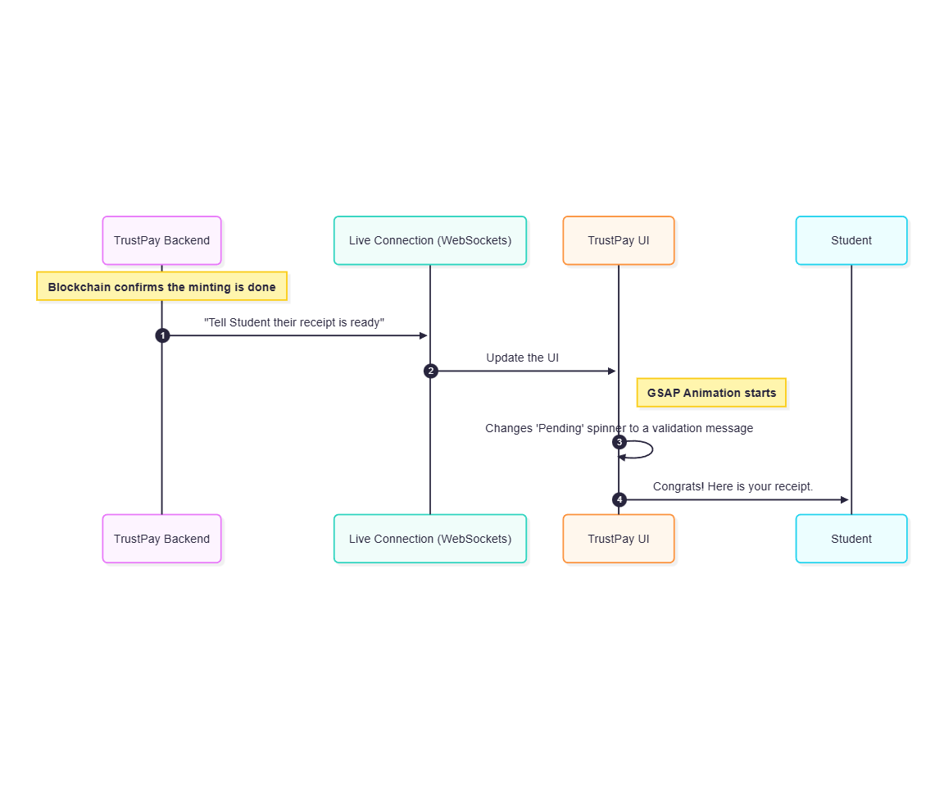Figure 4: Live Receipt Notification sequence diagram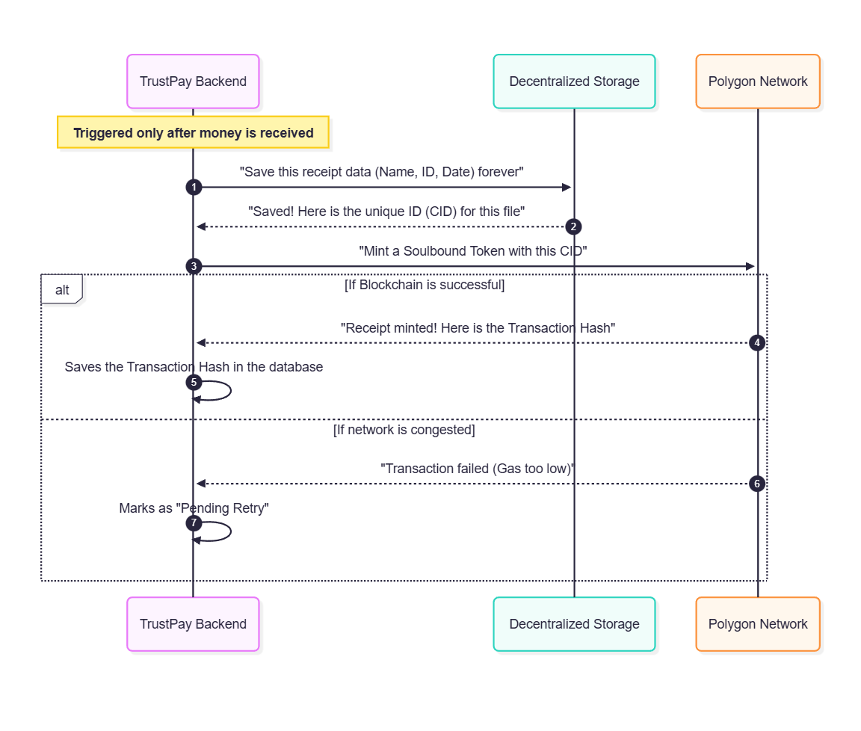Figure 5: Minting the SoulBound Token

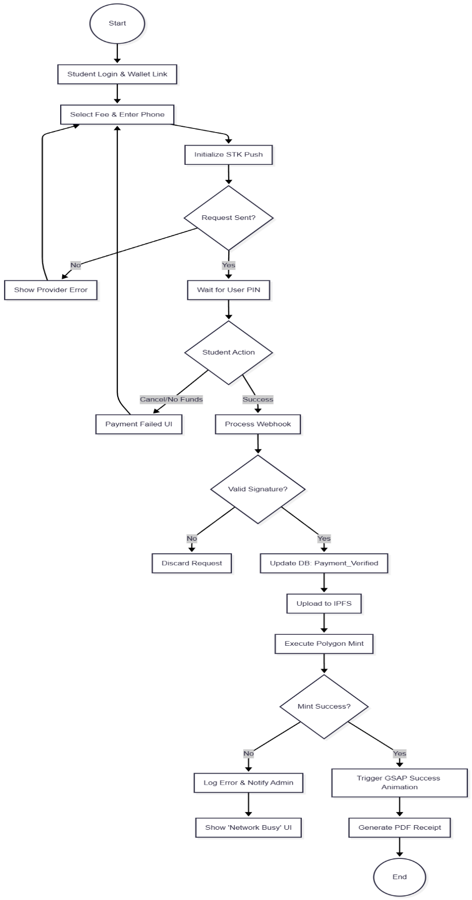
3.5.7 Activity Diagram
Figure 6: Activity Diagram

3.6 System Design
The system design for TrustPay follows a Layered Architecture (Client-Server-Blockchain). This separation ensures that the frontend remains high-performance while the backend handles the sensitive logic of verifying payments and interacting with the Polygon network.

3.6.1 System Architecture
The architecture is divided into four main layers to ensure security and scalability:
- Presentation Layer (Frontend): Built with React.js, Tailwind CSS, and GSAP. It manages the user state and interacts with the student's MetaMask wallet.
- Application Layer (Middleware): A Node.js/Express server hosted on Render. This acts as the manager, receiving webhooks from MoMo and sending instructions to the blockchain.
- Data Persistence Layer: Uses MongoDB Atlas for transaction logging and IPFS (via Web3.Storage) for decentralized metadata storage.
- Blockchain Layer: The Polygon Amoy Testnet where the ERC-5192 Smart Contract resides, ensuring receipts are non-transferable and immutable.

3.6.2 System Design Strategy
- Role-Based Access Control (RBAC): Access to the administrative verification portal is restricted to authorized university wallets.
- Event-Driven Minting: The system uses a "Listen-and-Trigger" strategy where the minting process only starts once a successful webhook event is captured.
- Stateless Frontend: The React UI fetches real-time data from the blockchain and MongoDB, ensuring that the student always sees the most current transaction state.

3.6.3 Class Diagram
This diagram shows the relationship between the main objects in the code.
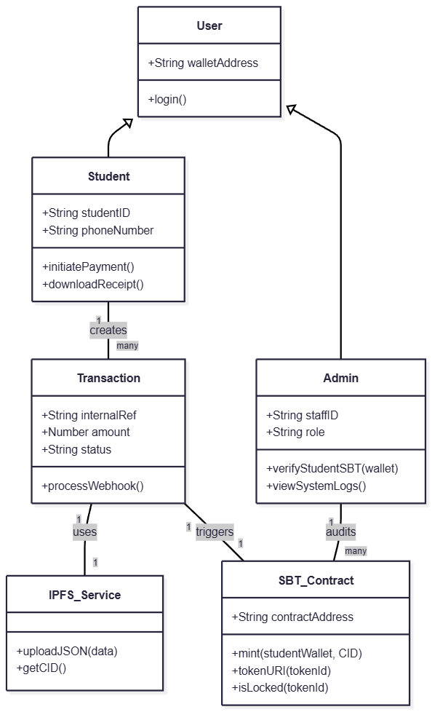
Figure 7: Class Diagram
3.6.4 Entity-Relationship Diagram (ERD)
This diagram defines how the data is stored. Note that Student is linked to Transactions, while the Admin exists as a separate entity with permissions to view the logs and verify tokens.
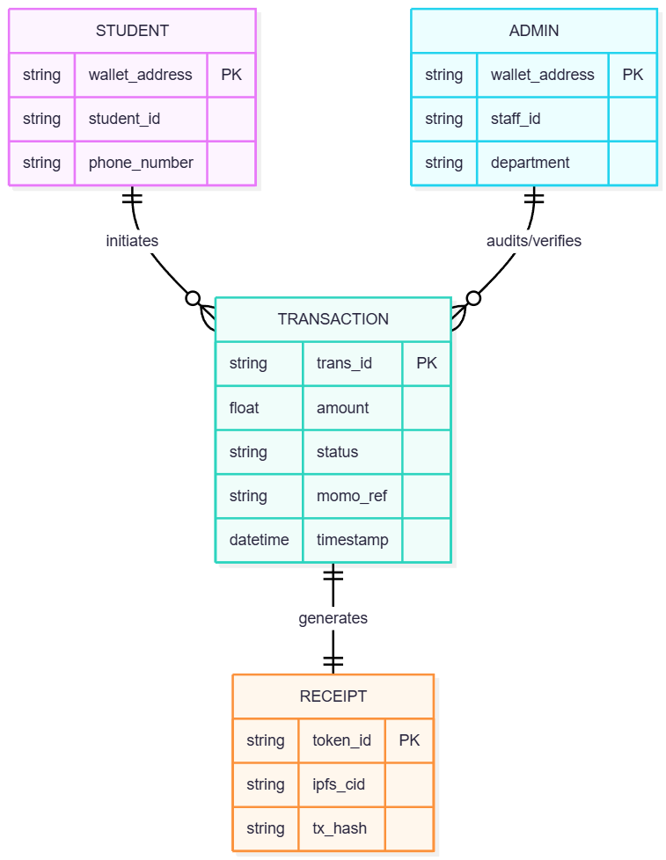
Figure 8: ER Diagram

3.6.5 Data Dictionary
This table stores the profile information for users identified as students.
Attribute | Data Type | Constraint | Description
walletAddress | String | Primary Key / Unique | The student's MetaMask public key.
studentID | String | Unique / Required | The official university registration number.
fullName | String | Required | The student's legal name.
phoneNumber | String | Required | The phone number used for MTN/Orange MoMo.
faculty | String | Optional | The academic department of the student.
Table 1: Student Entity

This table stores the profile information for university officials.
Attribute | Data Type | Constraint | Description
walletAddress | String | Primary Key | The administrative wallet authorized to verify tokens.
staffID | String | Unique / Required | Official employee identification number.
role | String | Enum | Defines permissions (e.g., "Bursar", "Registrar").
department | String | Required | The specific office the admin belongs to.
Table 2: Admin Entity

This table logs the lifecycle of a payment from initiation to minting.
Attribute | Data Type | Constraint | Description
transID | String | Primary Key | Internal UUID generated for tracking.
studentWallet | String | Foreign Key | References the Student's wallet address.
amount | Number | > 0 | The fee amount in XAF.
feeType | String | Required | Category of payment (Tuition, Medical, etc.).
momoRef | String | Unique | The external reference ID returned by the MoMo API.
status | String | Enum | [Initiated, Pending, Verified, Failed, Minted].
createdAt | DateTime | Auto-generate | Timestamp of when the request was made.
Table 3: Transaction Entity
This data is stored as a JSON file on IPFS. The hash (CID) is then linked to the Blockchain.
Field | Data Type | Description
name | String | Display name of the NFT/Receipt (e.g., "LMUI Tuition Receipt").
description | String | A brief summary of the payment and its validity.
image | String (URL) | The IPFS URL to the visual receipt graphic.
studentID | String | The student ID embedded in the metadata for verification.
paymentDate | String | The human-readable date of the successful transaction.
txHash | String | The blockchain transaction hash for cross-referencing.
Table 4: Receipt Metadata
These represent the variables stored directly within the Solidity Smart Contract.
Variable Name | Data Type | Visibility | Description
_tokenIds | Counters | Private | Incremental counter to assign unique IDs to each SBT.
owner | Address | Public | The address of the University wallet (Admin).
tokens | Mapping | Private | Maps a Student's address to their specific Token ID.
isLocked | Boolean | Public | Constant value true (as per ERC-5192) to prevent transfers.
Table 5: Smart Contract State

